Educator Copy

to Teach Ag Ed
Lesson Description:
- Students will explore the career of an agriculture educator by using a real-life website, LinkedIn.

Target Audience:
- Ag I & Ag II classes (freshman and sophomores.)

Lesson Directions:
- Display lesson objective: “Prepare a LinkedIn profile that includes criterion for the career of an agricultural educator.”
- Introduction: Ask students what they want to be when they grow up. Allow for group discussion. Share with students what career you desired to be when you were their age. Then, describe your path to become an agricultural educator.
- State that today’s lesson will focus on the career of an agricultural educator.
- Using a smart board or student Chromebooks go to the website https://www.linkedin.com. (Check prior to ensure the school server does not block the website.)
- Explain the concept of LinkedIn to students while navigating the website.
LinkedIn: a professional networking website where individuals can learn about job openings, promote their careers through online profiles and join organizations (such as the University of Missouri if a person graduated from that school.) This is similar to a digital resume.
- Show students your personal LinkedIn if applicable. (See photo.)

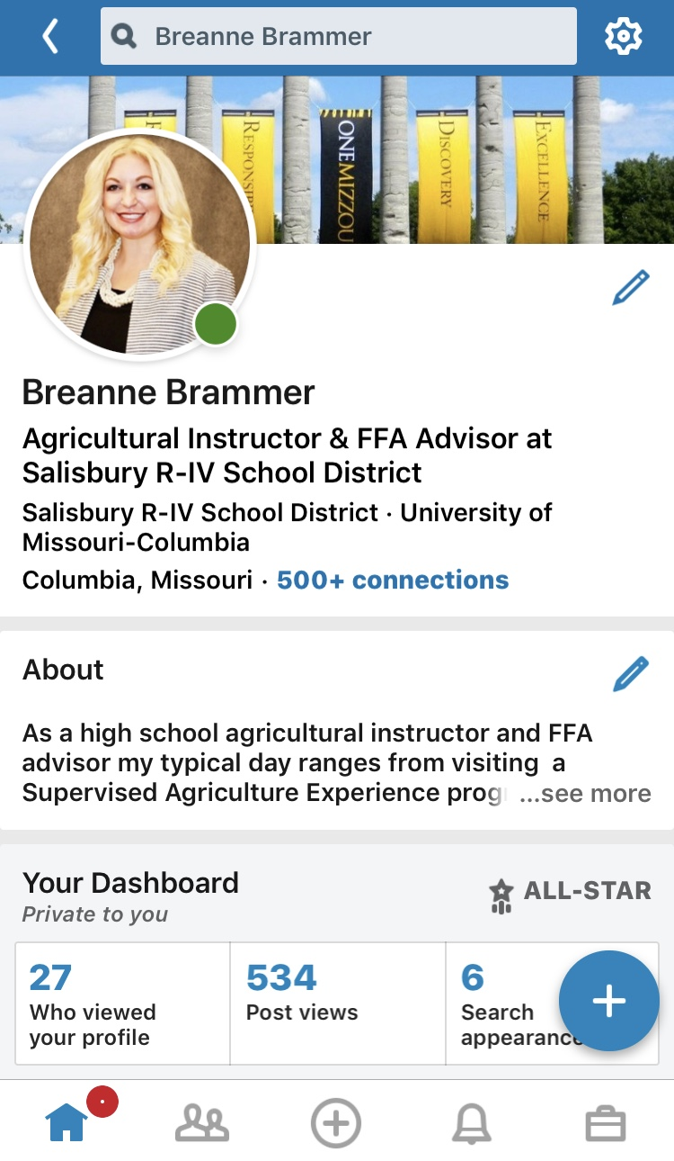
- Identify the major components of LinkedIn with corresponding to examples on the Smart Board:

LinkedIn Components:
- Identification Photo: Professional headshot, similar to a Facebook “profile picture.”
- Cover photo: horizontal photo indicating an interest relevant to the career
- Job description: Brief description of your career
Example: Agriculture Educator Teachers
- About: A section that allows for a brief paragraph to explain yourself.
“As a high school agriculture educator my typical day ranges from visiting a Supervised Agriculture Experience Program at a family farm to conducting a greenhouse lesson or even overseeing parliamentary procedure during a chapter meeting. My interest in agricultural education and the National FFA Organization began as a kindergartener when I saw my first blue corduroy jacket at my hometown’s FFA Week celebration. That passion led me to become an FFA member and to my current role as an agricultural instructor and FFA advisor.”
- Experience: List relevant work experience
Example: Missouri State FFA Officer
- Education: State educational schools attended such as college
Example: University of Missouri
- Licenses & Certificates: List relevant additional certifications to your career
Example: Missouri Boaters License
- Volunteering: Describe community service
Example: Columbia Animal Shelter
- Skills & Endorsements: State proficient skill sets relevant to your career
Example: Microsoft Word
Example: Your former business teacher could endorse you for this skill because they recognized your aptitude for Microsoft products in class.
- Accomplishments: Relevant awards
Example: Star Greenhand
- Contact: List the ways in which you would like an employer to reach you for a job.
Example: AgTeacher1928@yahoo.com
- Interests: Hobbies or causes outside of your career that are of interest
Example: Mountain biking

Assignment Directions:
- After going through the components of a LinkedIn profile with students tell them it is their turn to create a profile. Using the student copy they are to create a complete the digital profile using a Chromebook/computer. (Be sure to upload the student copy to Google Classroom.) They will not be using the LinkedIn website directly, instead they will complete their information on the attached student copy.
- Students are to take the role of an agriculture education teacher when creating this “LinkedInto Ag Ed” digital profile.
- All information should be realistic to the career of an agriculture educator.
- Students are to complete all components of the LinkedIn sheet.

Sources
- Encourage student to obtain information for their profiles from the following sources:

https://www.naae.org/teachag/
http://www.moteachag.org
https://missouriffa.org
https://dese.mo.gov/educator-quality/certification/routes-certification
https://www.universities.com/find/missouri/best/agriculture

Assignment Grading:
- Before allowing students to start “linking” to ag ed, review the assignment grading criteria. Students will be assessed on the following rubric:

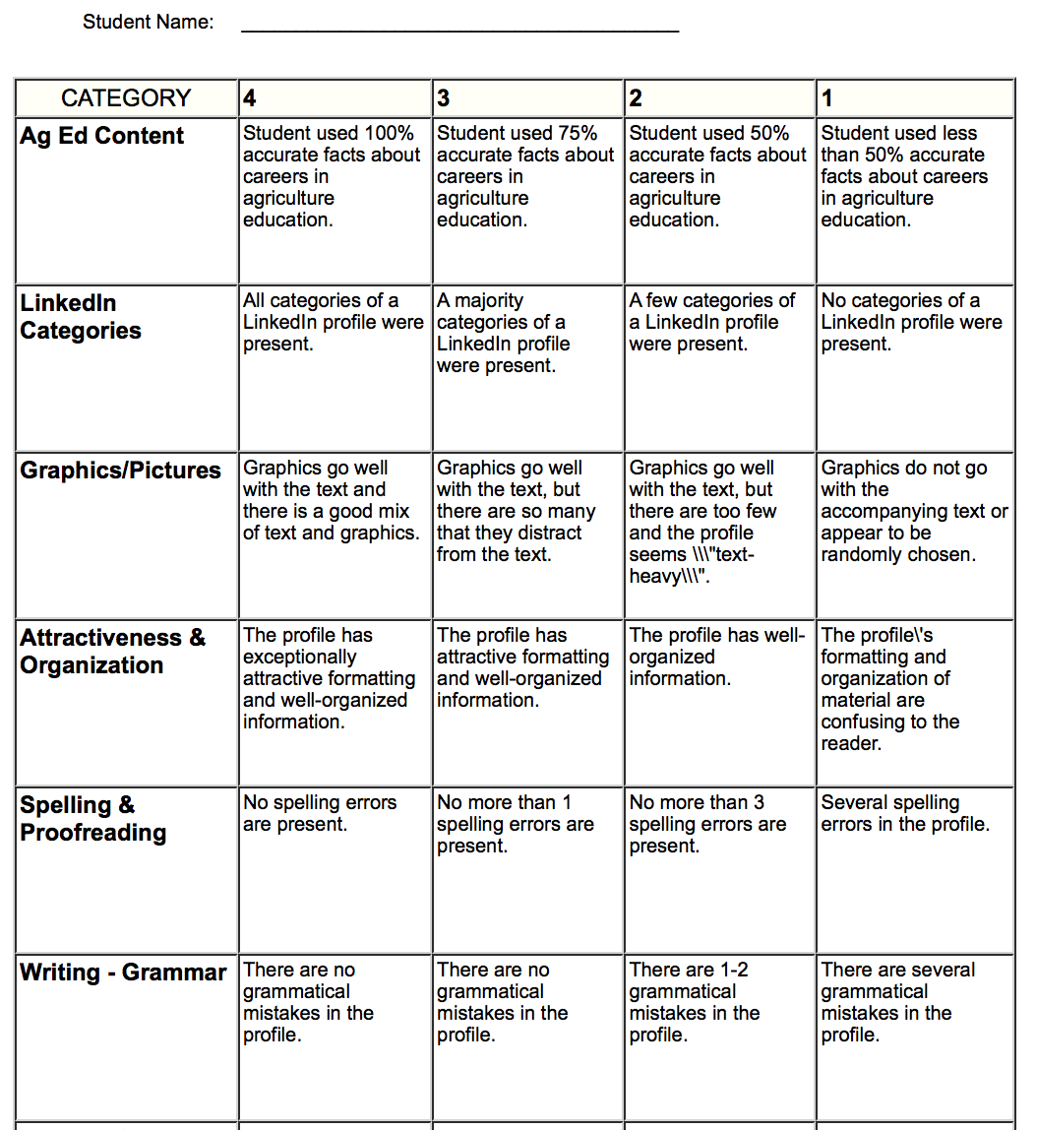

Promoting Assignments:
- After students have completed their assignments, share them to your school district or FFA Chapter’s Facebook page on National Teach Ag Day!
- Be sure to use the hashtag #TeachAgEd or #Tagged19.
- Optional: The school principal can choose which agricultural educator they would select to hire based on their profile at your high school.
Student Copy
to Teach Ag Ed

Identification Insert a cover photo here

Insert a photo to use as your identification photo
Your name
Job Title
About
Experiences
Education
Licenses & Certifications
Volunteerism
Skills & Endorsements
Contact Information
Accomplishments
Interests

